Documentation

Development of employment levels (geringfügige Beschäftigung):



🡪 many, but not all, Bundesländer have seen an increase in the employment level for low wage work since the wave of refugees

Development of the number of refugees relative to the population in each Bundesland:



Difference in Refugees relative to the Population between 2014 and 2016:

Ein Bild, das Tisch enthält.

🡪 two Bundesländer which would be good for comparison are Mecklenburg-Vorpommern and Schleswig-Holstein as they are very comparable since they are located next to each other and have a comparable size. Also they are on opposite ends regarding the change in refugees per population

🡪 another idea would be to compare Mecklenburg-Vorpommern and Bremen since they took in the least and most refugees relative to their population, respectively. However, one is a city and one is not densely populated so they may not be directly comparable.

Development of refugees relative to the population in Germany and Switzerland:



🡪 we can see that Germany took many more refugees in than Switzerland

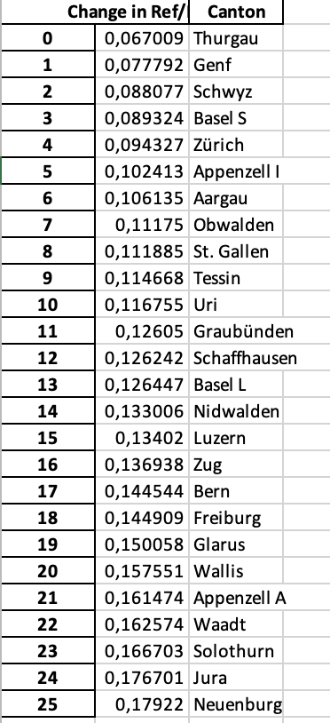

* Genf & Waadt oder Solothurn & Aargau

Results National Data

In order to validate the necessary common trend assumption, we looked at the development over time of the unemployment rate, the total employment level and the employment level of foreigners in Germany and Switzerland.

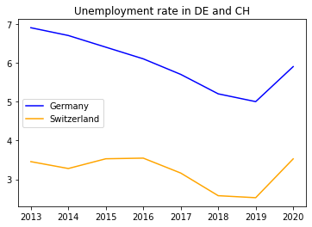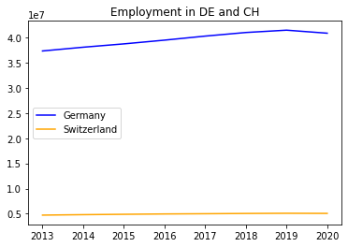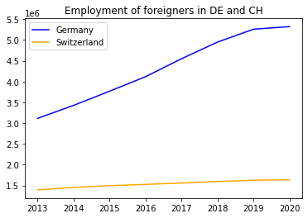

As one can see, the trends pre-2015 are similar but not all the same. However, we can make the assumption that Switzerland and Germany are comparable since they have similar demographics, institutions etc.

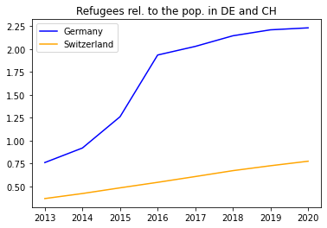

When we look at the number of refugees relative to population size, we can see a development as expected. The numbers in Germany increase exponentially from mid-2014 while they only increase linearly in Switzerland. After 2016 this exponential trend levels off.

Next, let us look at the results of the ATET estimation.

The ATET for **Total Empl is 1,262,062**

The ATET for **Total Empl Foreigners is 616,629**

The ATET for **Unemployment Rate is -1.0**

Assuming that all identifying assumptions hold, we can see that the influx of refugees led to an increase in the total employment level by approximately 1.3m and an increase in the employment level for foreigners by approximately 0.6m. It is interesting that the effect is almost twice as large on the total level of employment. Perhaps this is because the refugees took on jobs in industries which were either desperately in need of workers and/or which are supporting industries to other industries, hence, boosting the total employment level. Considering that between 2014 and 2016 there was an influx of ﻿851,250 refugees, we can make the assumption that many of them found work since the size of the ATET for the employment of foreigners is ﻿72.4% as large as the increase in refugees.

And finally, we can have a look at the effect of the influx of refugees on the employment level of low-wage jobs (“geringfügige Beschäftigungsverhältnisse”). This was estimated with an OLS regression where *Total Empl (geringfügig)* is the dependent variable. As independent variables we chose *Total Population, Total refugees, without educ* and *Year* since the low-wage employment level can also be influenced by the development of the total population as well as the number of people without education.

OLS Estimation Results:

--------------------------------------------------------------------------------

Dependent Variable: Total Empl (geringfügig)

--------------------------------------------------------------------------------

coef se t-value p-value

intercept 1.847465e+08 1.244494e+08 1.48 0.23

Total Population -2.100000e-01 3.200000e-01 -0.65 0.56

Total refugees 3.600000e-01 4.600000e-01 0.79 0.49

without educ 1.820000e+00 7.600000e-01 2.38 0.10

Year -8.084253e+04 6.675112e+04 -1.21 0.31

We can see that the number of refugees has a small (0.36) and not statistically significant effect on the level of low-wage employment. Surprisingly, the effect of the year is much larger (﻿-80,843) and negative. Maybe this is because there have been policies on reducing low-wage employment and instead encourage and help people to go into jobs which are subject to social insurance contributions (“sozialversicherungspflichtig”). However, this coefficient is also not statically significant as the p-value is larger than 0.1. The only effect which is statistically significant is the effect of the number of people without education on the level of low-wage employment, yet this is also very small (1.8).

Results Regional Data

Next, we will have a look at the results on a regional level. First, we decided to compare Mecklenburg-Vorpommern and Schleswig-Holstein in Germany where Schleswig-Holstein (SH) is the treatment “variable”. The results are the following:

﻿The ATET for **Total Empl is 3,707**

The ATET for **Empl Foreigners is 1,071**

The ATET for **Unemployment Rate is 1.0**

﻿﻿**36,285** refugees came into SH between 2014 and 2016.

Here we can see that the employment effect is much smaller than it was on the national level. This implies that most of the refugees which came into SH did not find any employment. This is also in line with the ATET for the Unemployment Rate which increased by 1.0 due to the refugee influx.

Following, we will have a look at the regional results for Switzerland. First, we compared the cantons Geneva and Vaud. Since there was no data available on the regional employment levels for the Swiss cantons, we could only conduct the ATET estimation on the unemployment levels. Additionally, we checked the effect on the number of B permits to see how much of the refugee influx translated into an increase of the permits B which allow foreigners to work in Switzerland.

﻿The ATET for **Unemployment is 309**

The ATET for **Unemployment Rate is 0.0**

**﻿**The ATET for **Residents Permit B Total is 834**

﻿**1,367** refugees came into Vaud between 2014 and 2016.

Here, the effect on the labour market was very small or even negligible since the effect on the Unemployment Rate was zero. More specifically, the incoming of 1,367 refugees translated into an effect on the amount of B permits of 834. Since we have a positive effect on the level of unemployment, this implies that most of the refugees with a permit B stayed unemployed.

And finally, let’s move to the results of our estimation using Aargau as the control and Solothurn as the treatment.

﻿The ATET for **Unemployment is -171**

The ATET for **Unemployment Rate is 0.0**

The ATET for **Residents Permit B Total is -390**

**479** refugees came into Solothurn between 2014 and 2016.

Again, we have a rather small effect on the labour market with an ATET for the Unemployment Rate of zero. Interestingly, we have a negative effect on the B permits which would imply that the incoming refugees had the effect of less inhabitants possessing a permit B.

Conclusion

Overall, the results suggest that the refugee crisis had a positive effect on employment levels, both generally and only considering foreigners. The effect on unemployment is more ambiguous. On a national level, we find that the large influx of refugees decreased the unemployment rate by 1.0 while on a regional level, we find that it depends on the region we look at. However, the labour market effects on a regional level in Switzerland are rather small or even almost non-existent. The ambiguity lets us question the experiment setup. It may be that especially on a regional level, the number of refugees which arrived in the region was too small to have any effect on the labour market (for example, in Solothurn there was only an increase of 479 people). Additionally, there may have been other labour market effects which we didn’t take into account such as policies trying to affect the un-/employment levels. However, to summarise it can be said that the refugee crisis most likely raised employment levels in the countries affected, thus, many refugees were able to find employment and start a new life.